## Output of the scripts

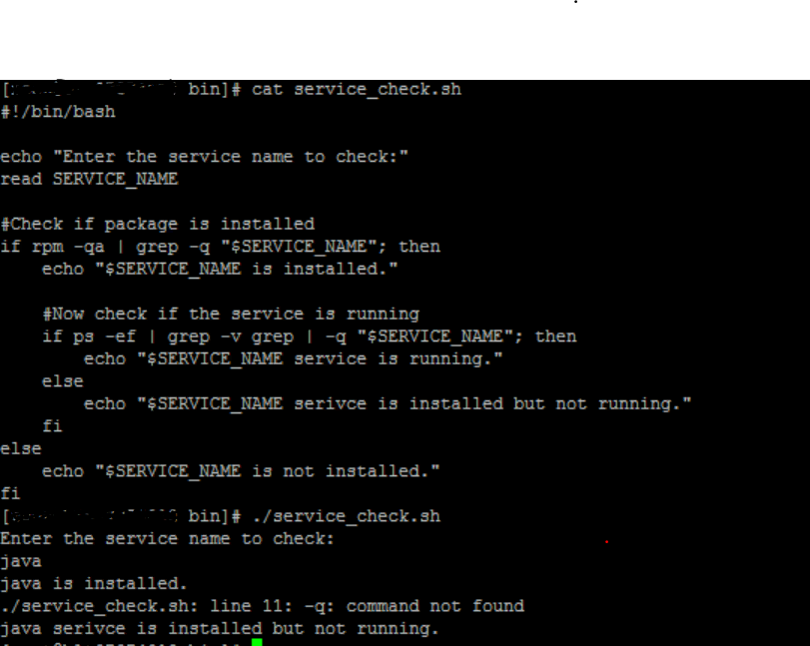

Output of the Service_check.sh script

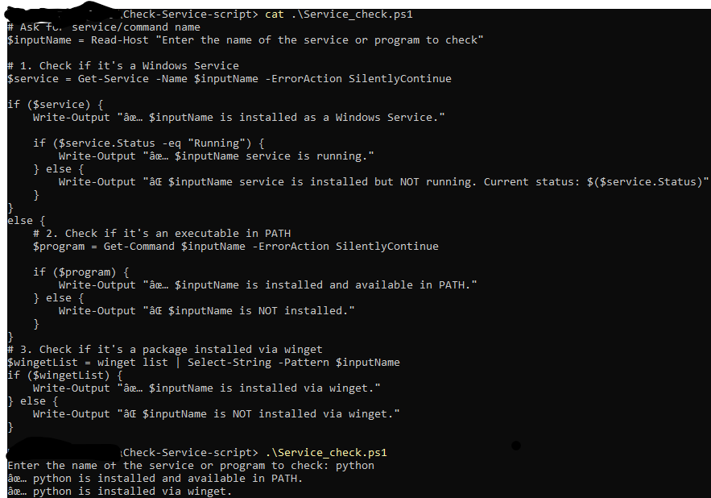

Output of the Service_check.ps1 script for windows powershell